Student Name – Ujjawal Shrestha

Course – Responsive Web Applications with Bootstrap & CSS

**Documentation of the course**

The webpage consists total of 9 pages named as: index.html, about.html, skills.html, education.html, projects.html, resume.html, gallery.html, references.html and contact.html. Breadcrumb and Navbar components are used in all of the 9 pages.

**Page:** Index.html

**Screenshots:**

**Large Size: Laptop**

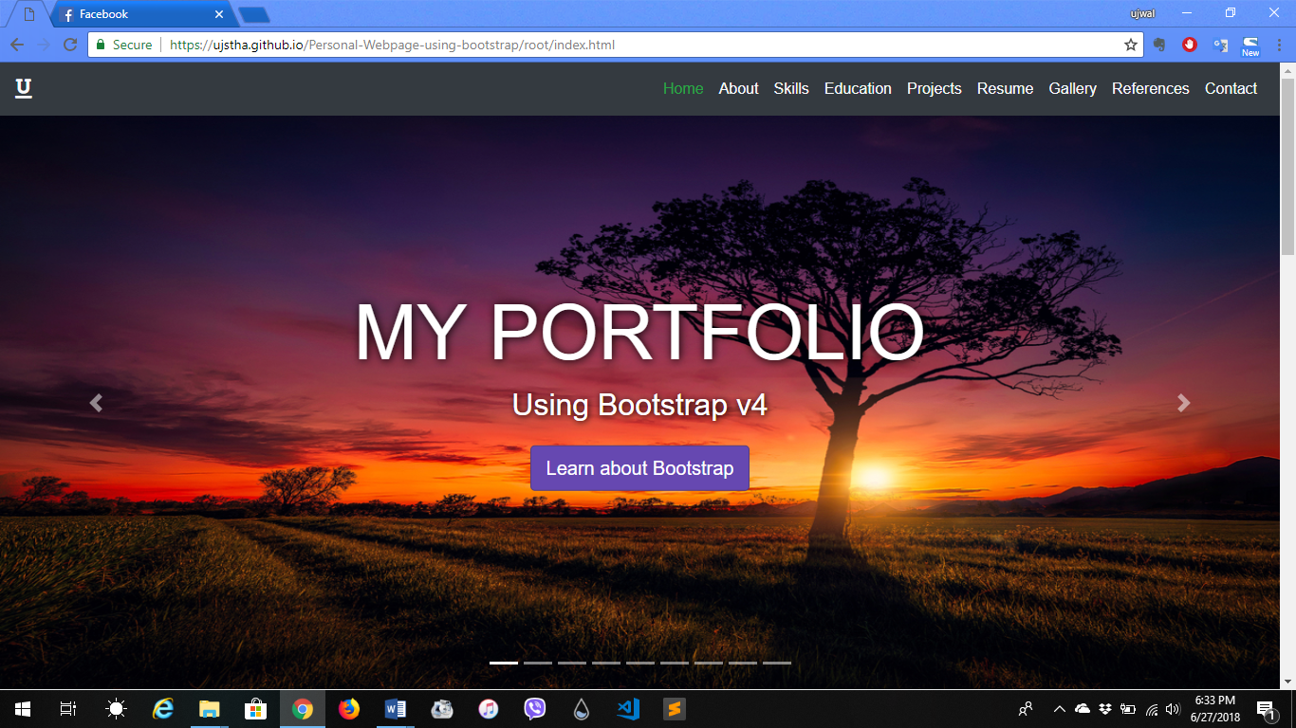

**Medium Size: iPad Pro**

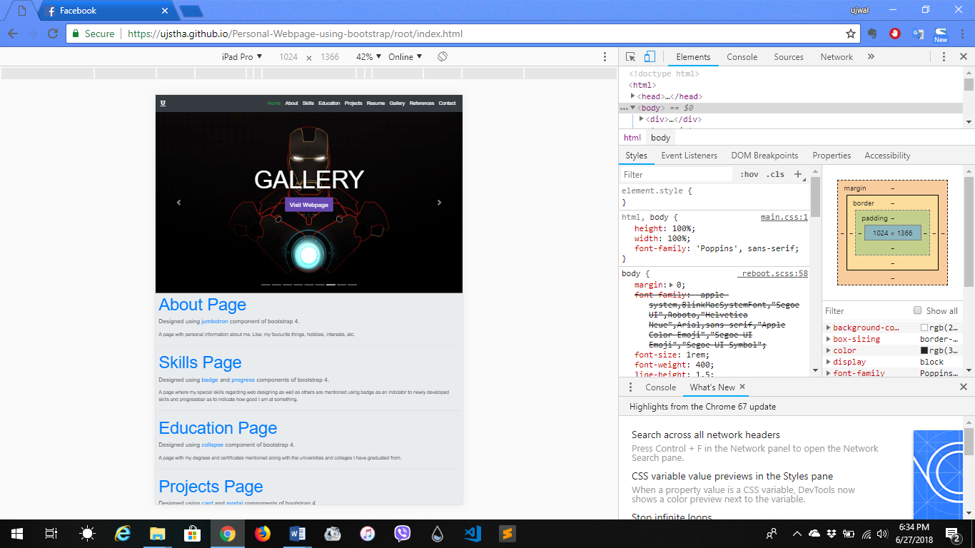

**Small Size: Galaxy S5**

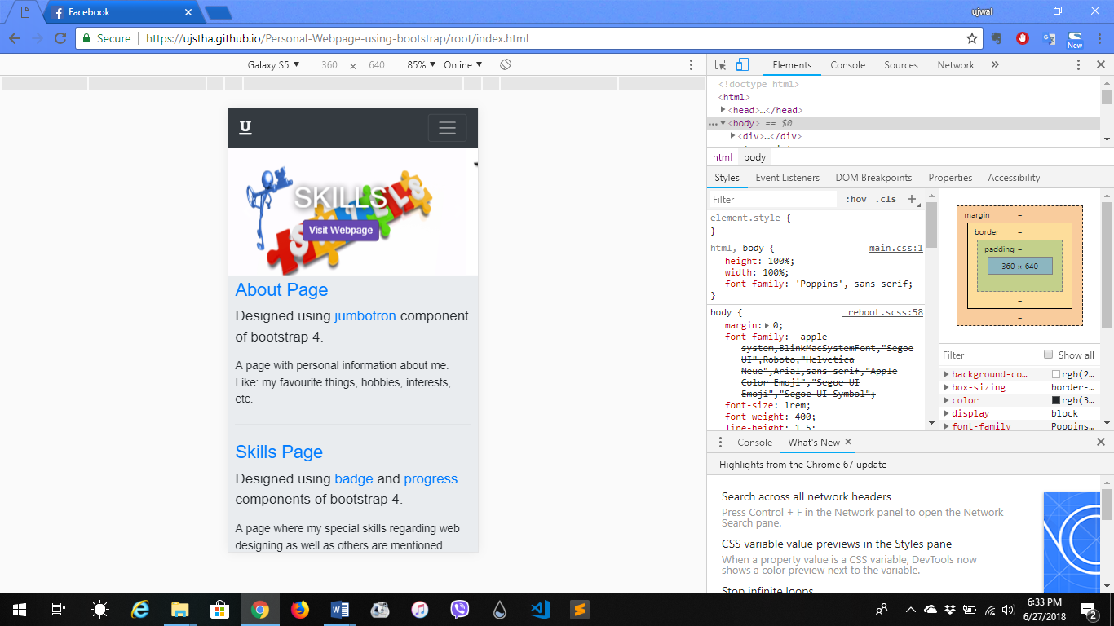

**Extra Small Size: iPhone X**

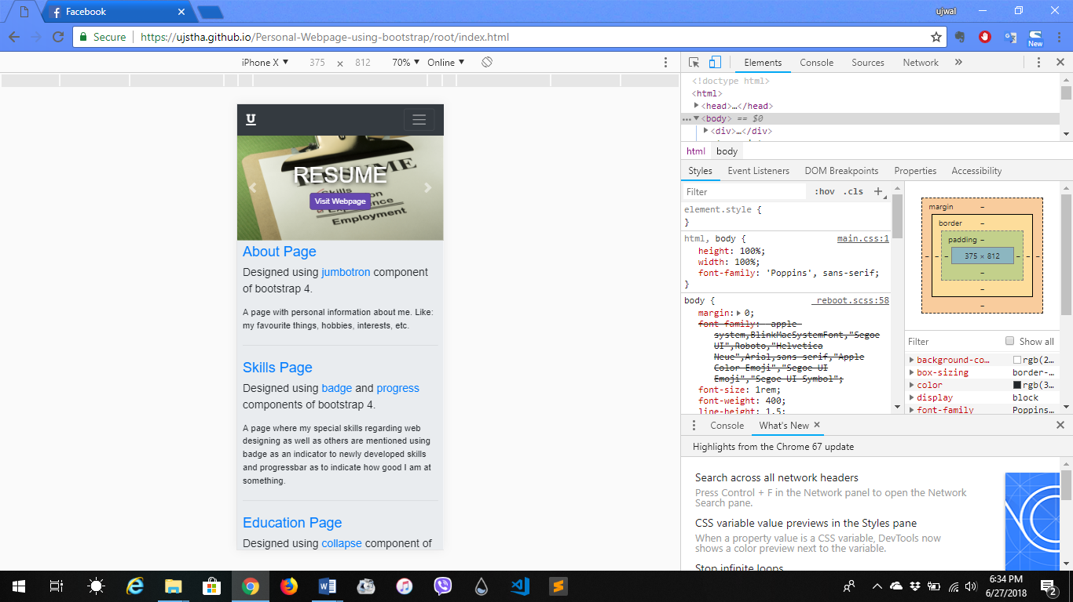

**Description:** This page is a sum of all the pages. It contains small description about all the other pages. It is built using Jumbotron, Carousel components of bootstrap. I learned about the use of bootstrap and how to insert it in the html tags and also to link the css and jquery cdn on html.

**Page:** About.html

**Screenshots:**

**Large Size: Laptop**

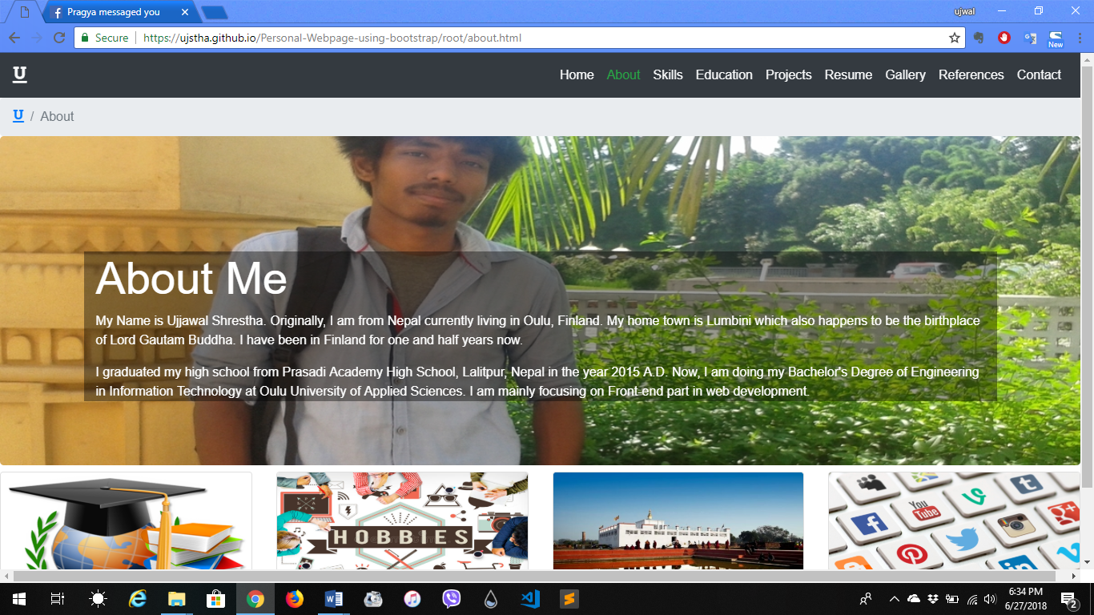

**Medium Size: iPad Pro**

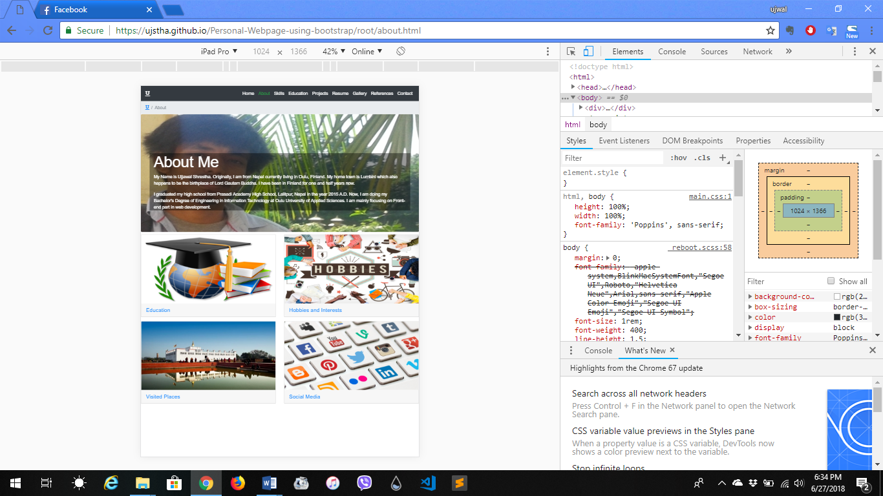

**Small Size: Galaxy S5**

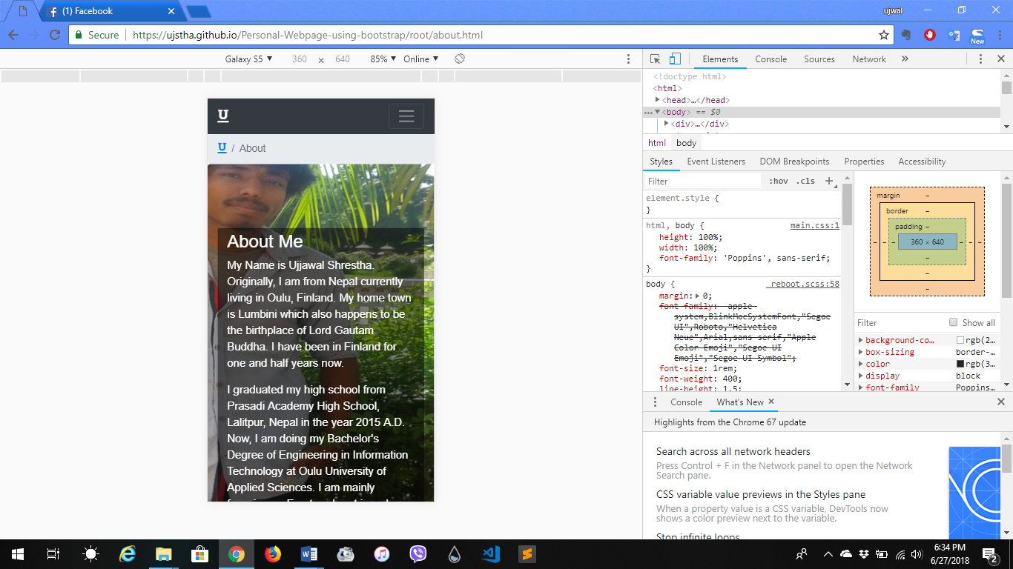

**Extra Small Size: iPhone X**

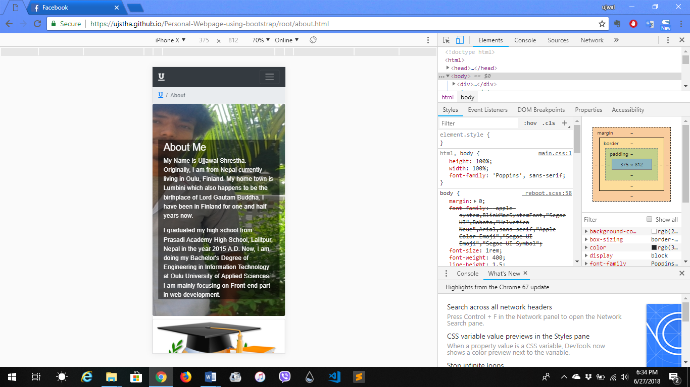

**Description:** This page is designed using jumbotron component of bootstrap. It is about me, my hobbies and interests, education, etc. Additionally, card and collapse components are used to categorize the titles.

**Page:** Skills.html

**Screenshots:**

**Large Size: Laptop**

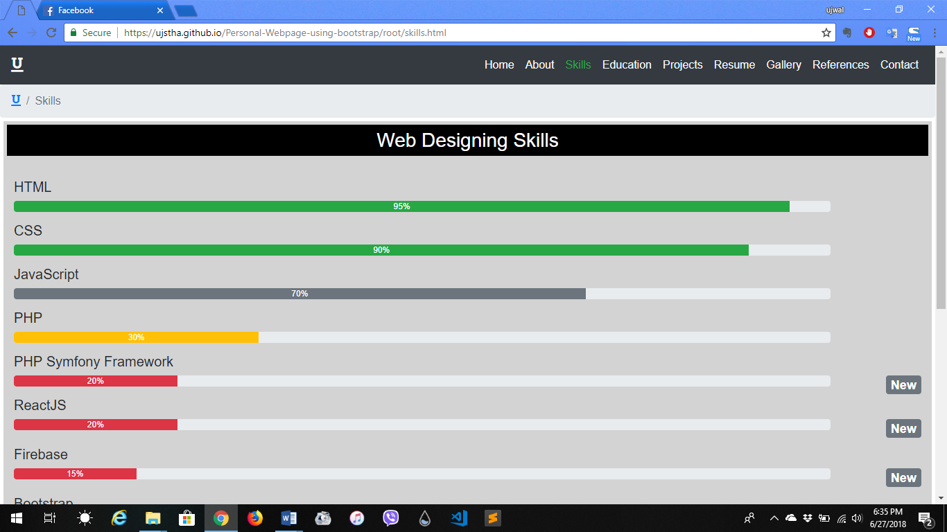

**Medium Size: iPad Pro**

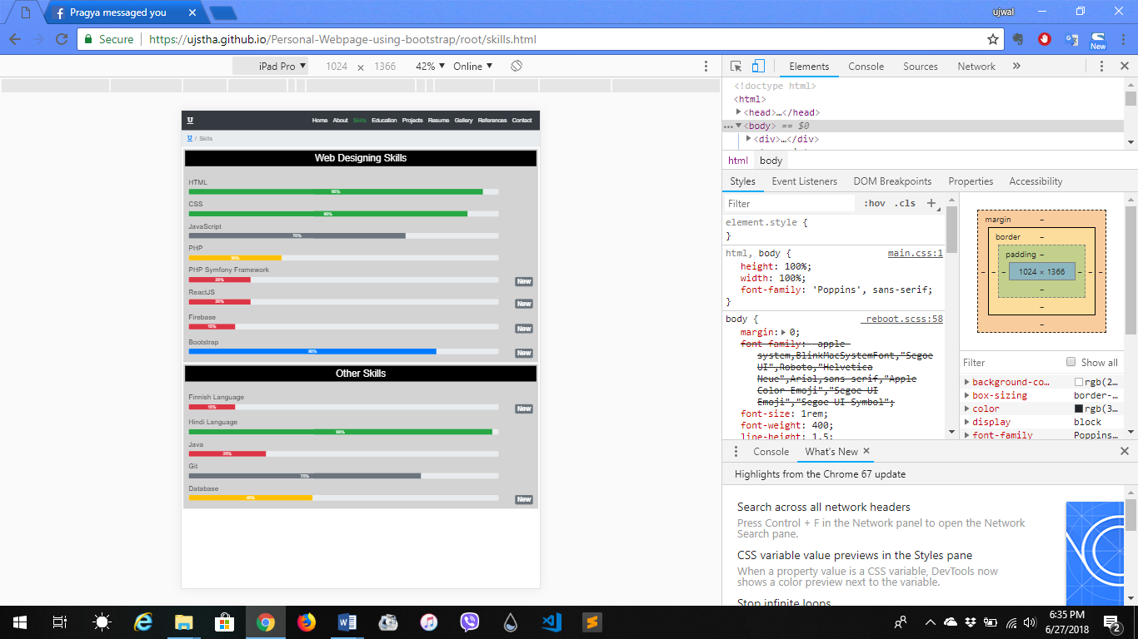

**Small Size: Galaxy S5**

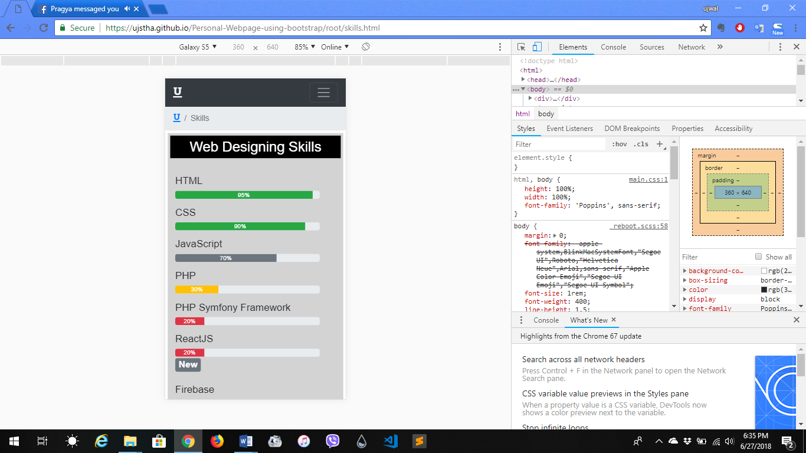

**Extra Small Size: iPhone X**

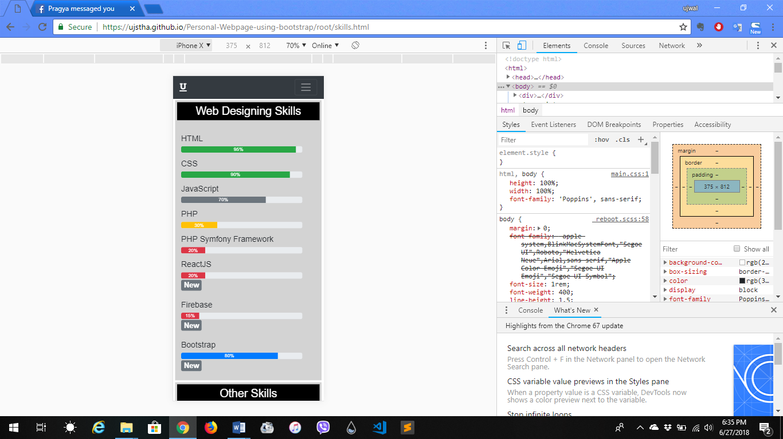

**Description:** This page is designed using Badge and Progress components. Badge is used to indicated newly gained skills and, progressbar is used to indicate how good I am at certain things.

**Page:** Education.html

**Screenshots:**

**Large Size: Laptop**

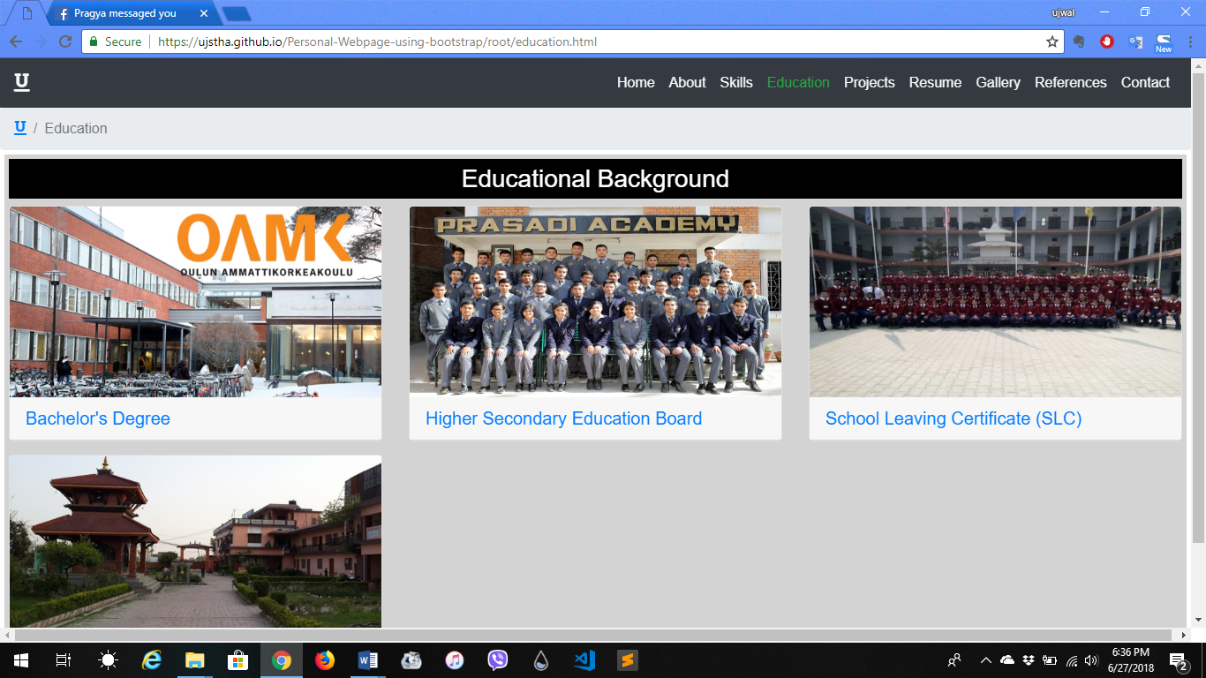

**Medium Size: iPad Pro**

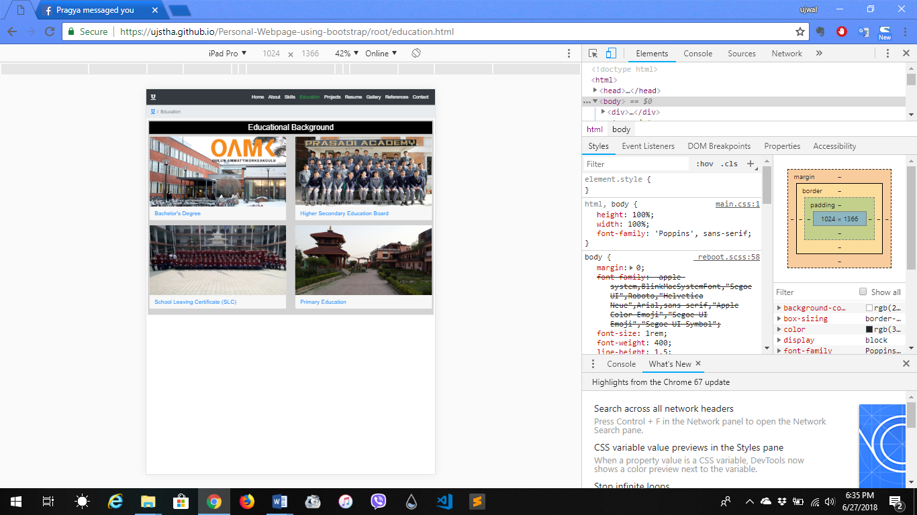

**Small Size: Galaxy S5**

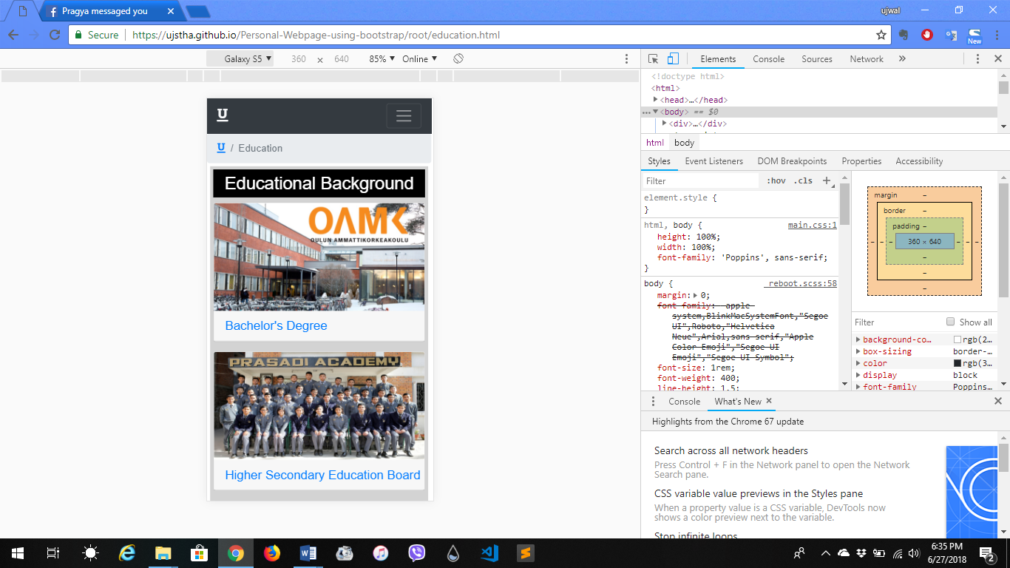

**Extra Small Size: iPhone X**

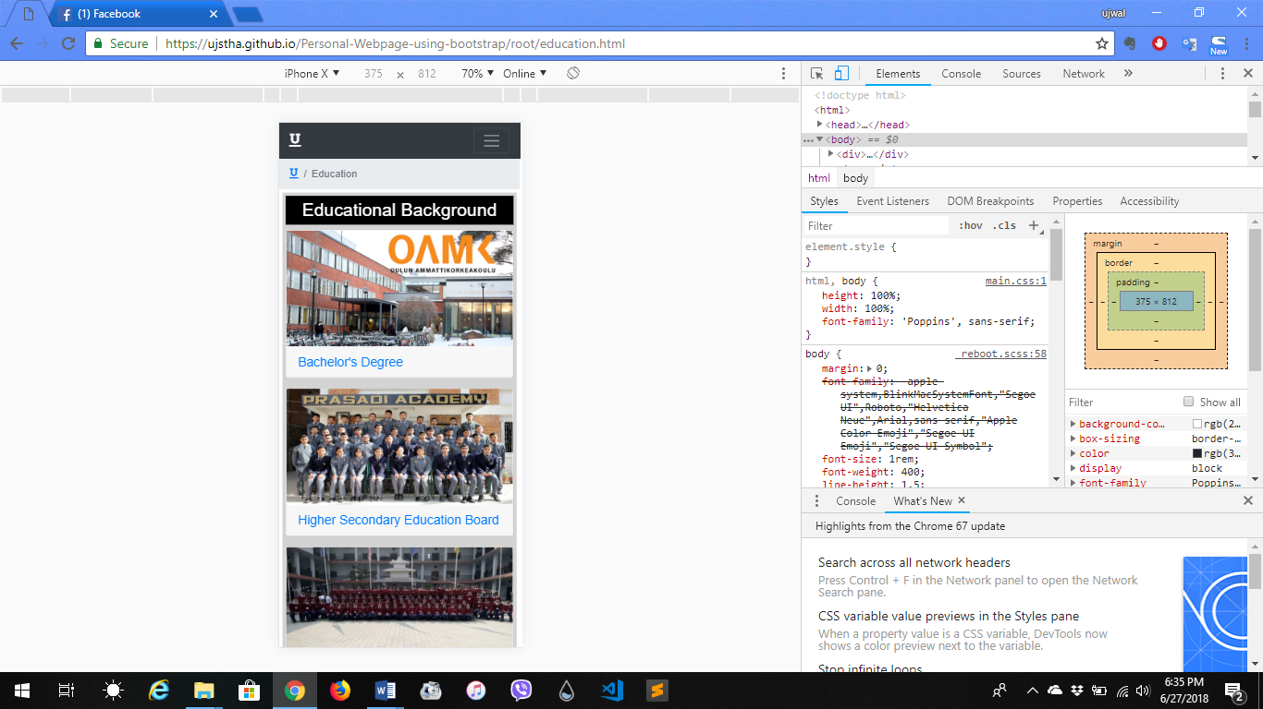

**Description:** This page is designed using collapse component of bootstrap. It shows my educational background. It shows which colleges or schools, where and when have I graduated from. Here, is my educational background from the beginning of my student life.

**Page:** Projects.html

**Screenshots:**

**Large Size: Laptop**

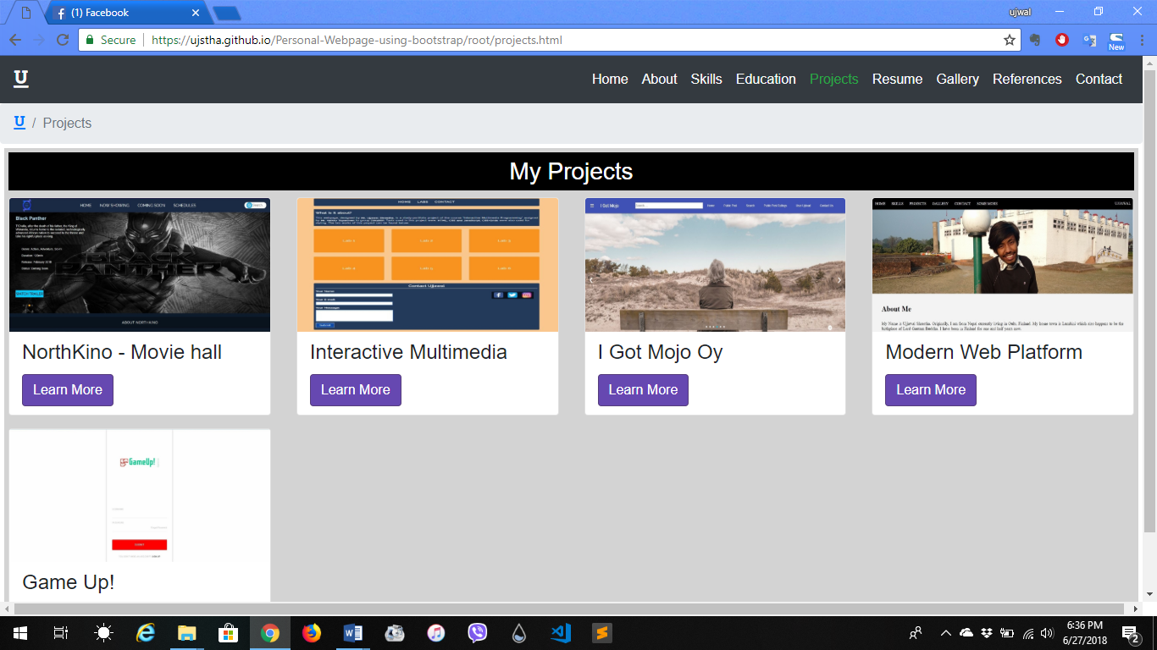

**Medium Size: iPad Pro**

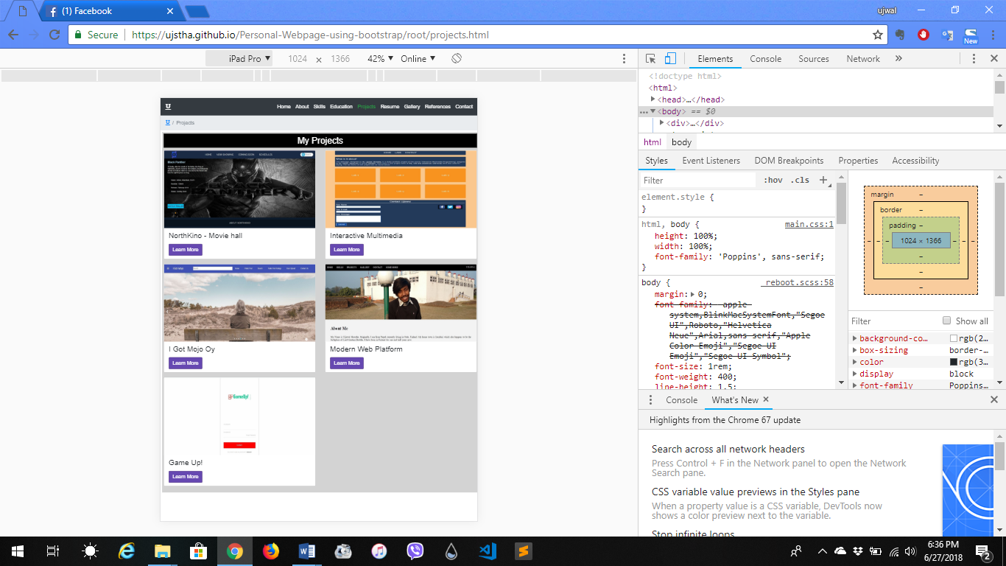

**Small Size: Galaxy S5**

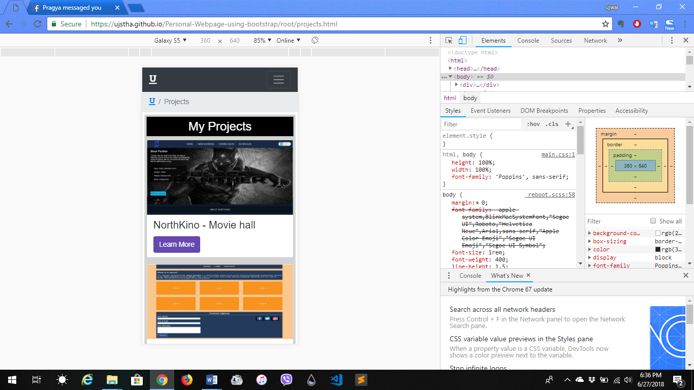

**Extra Small Size: iPhone X**

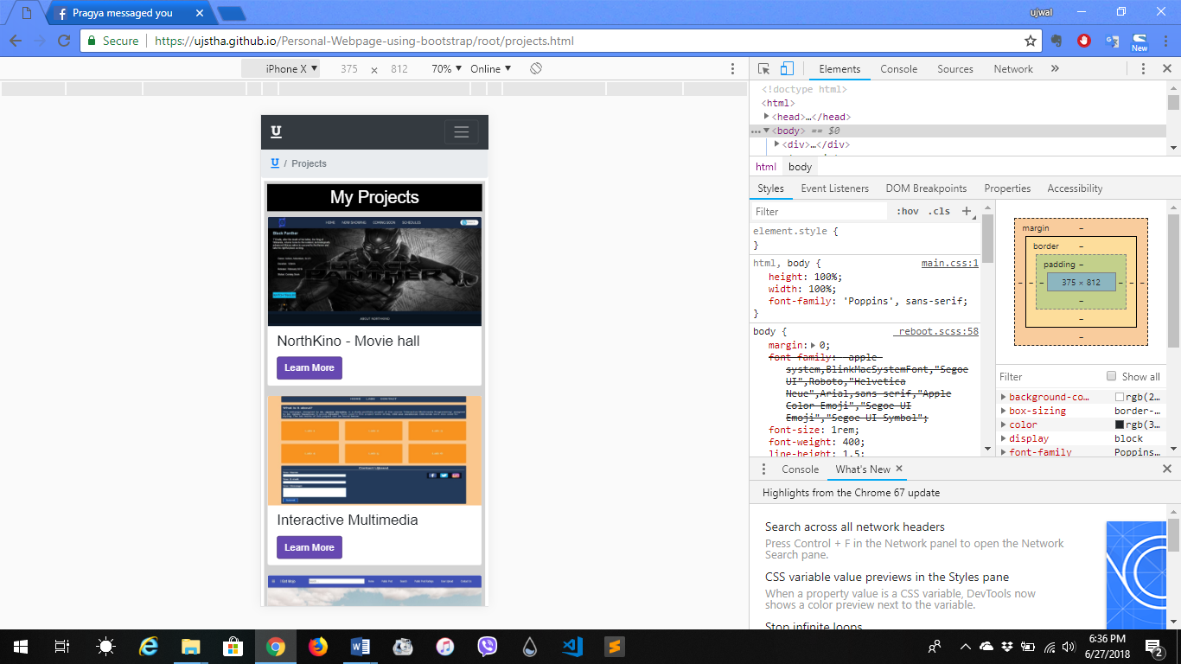

**Description:** This page is designed using Card and Modal component of bootstrap. It contains the list of projects I have worked on or am working on and a short description about those projects. Card is used to show the list and title of the project while Modal is used to give a brief description about a particular project.

**Page:** Resume.html

**Screenshots:**

**Large Size: Laptop**

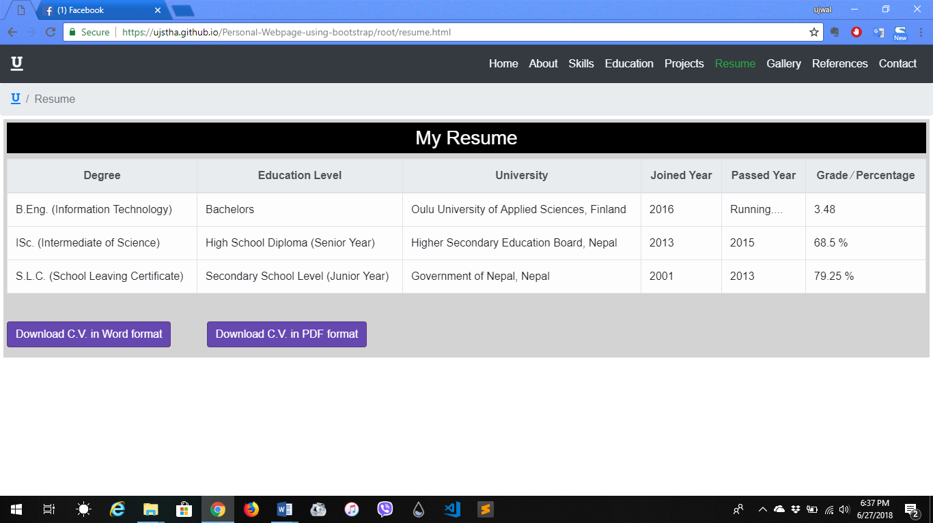

**Medium Size: iPad Pro**

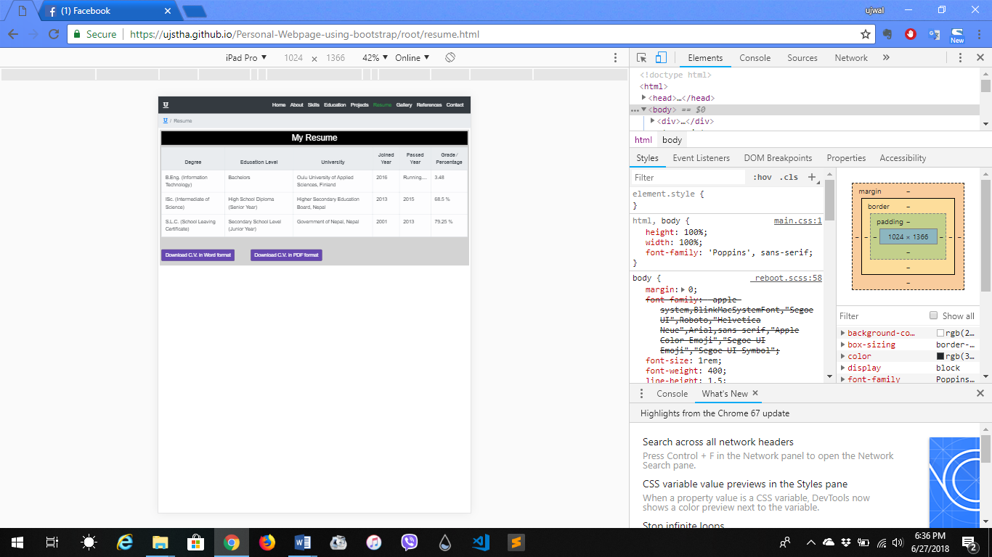

**Small Size: Galaxy S5**

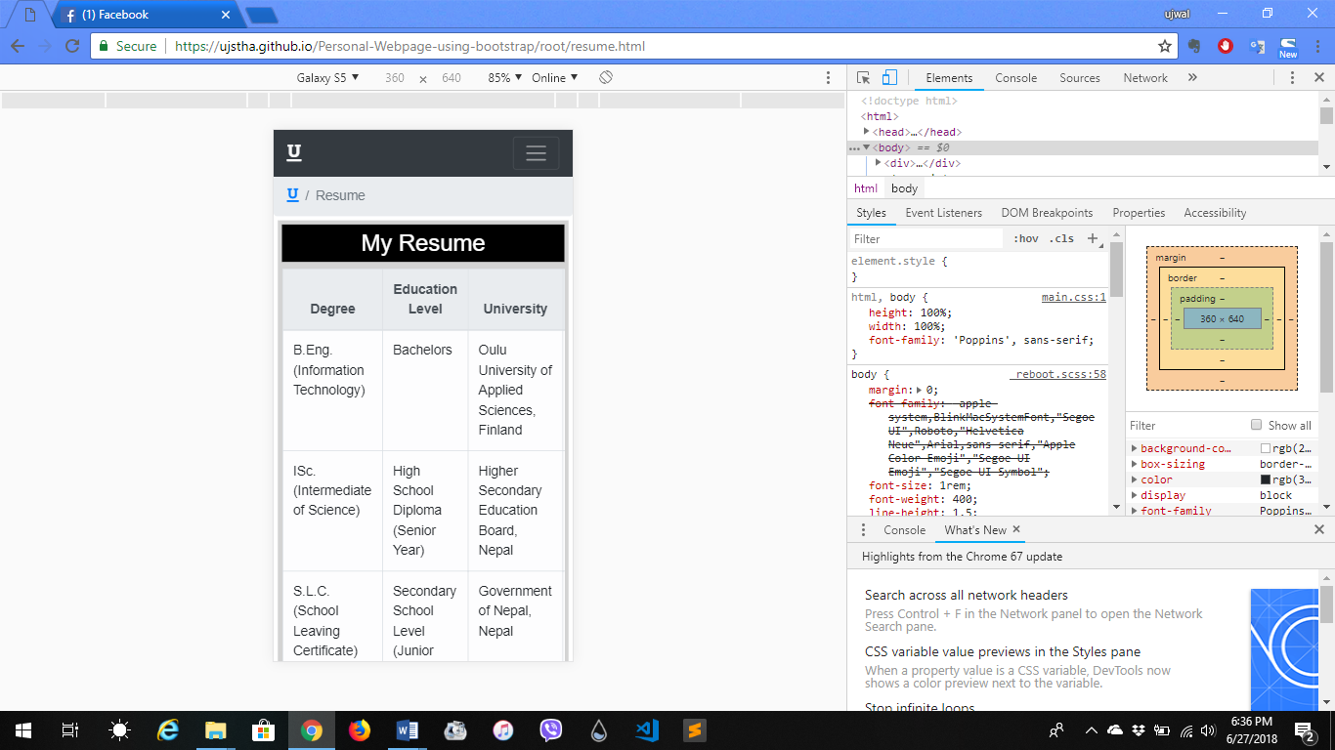

**Extra Small Size: iPhone X**

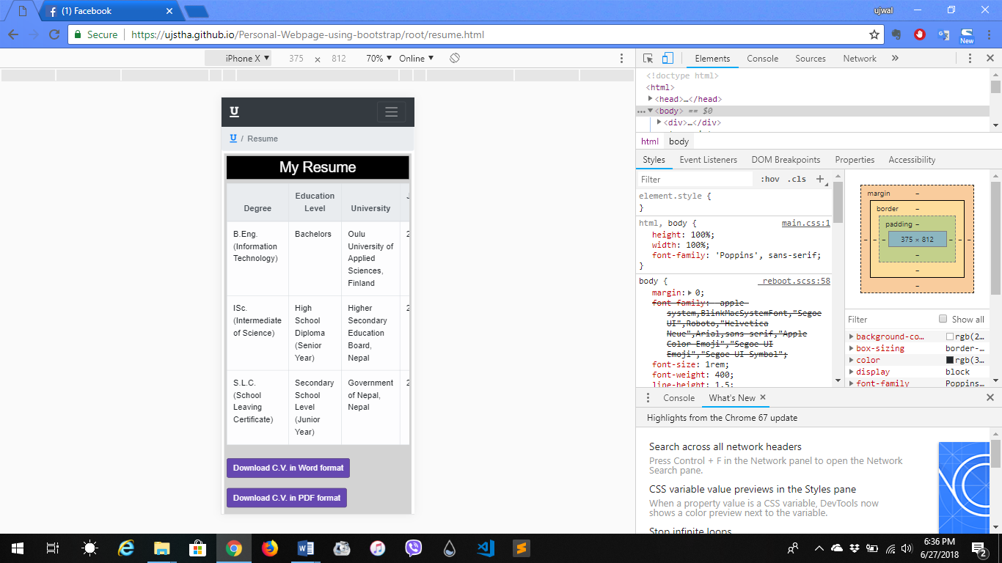

**Description:** This page is designed using Button group component and Table utility of boostrap. Button group is used to make a designed button which is used to view my C.V. in (.docx) format and PDF format. Table utility is used to list my achievements and practices in a table.

**Page:** Gallery.html

**Screenshots:**

**Large Size: Laptop**

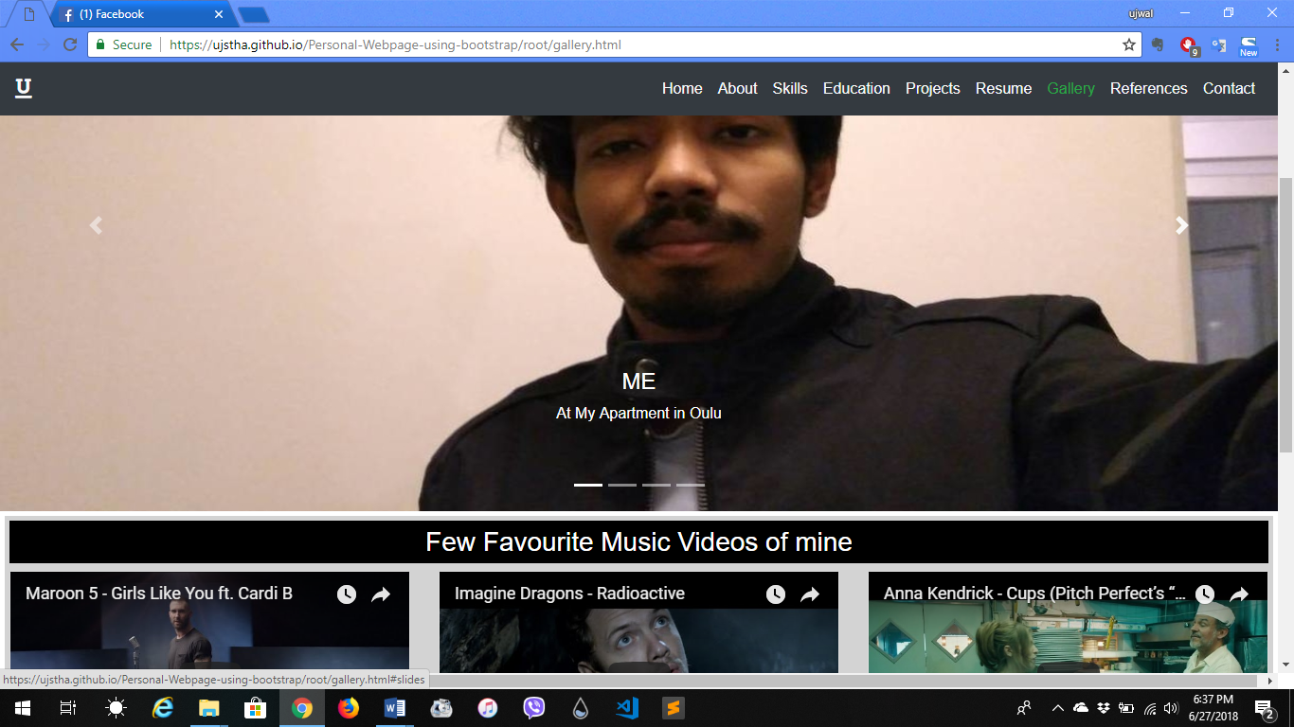

**Medium Size: iPad Pro**

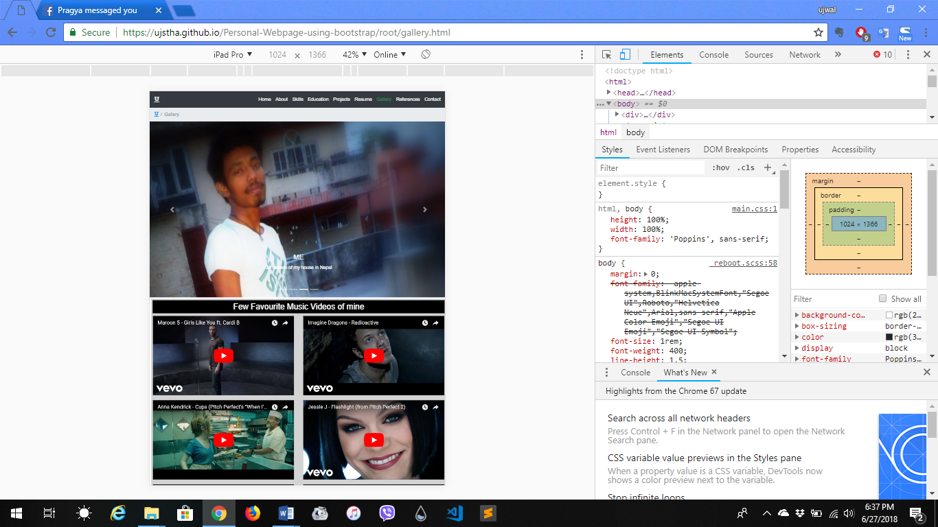

**Small Size: Galaxy S5**

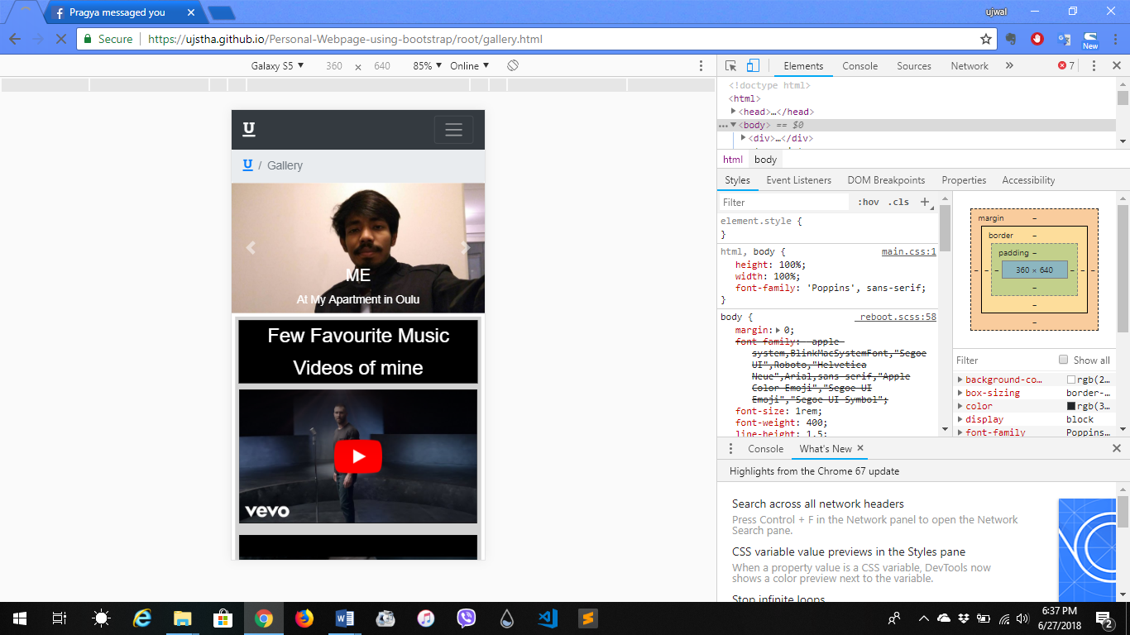

**Extra Small Size: iPhone X**

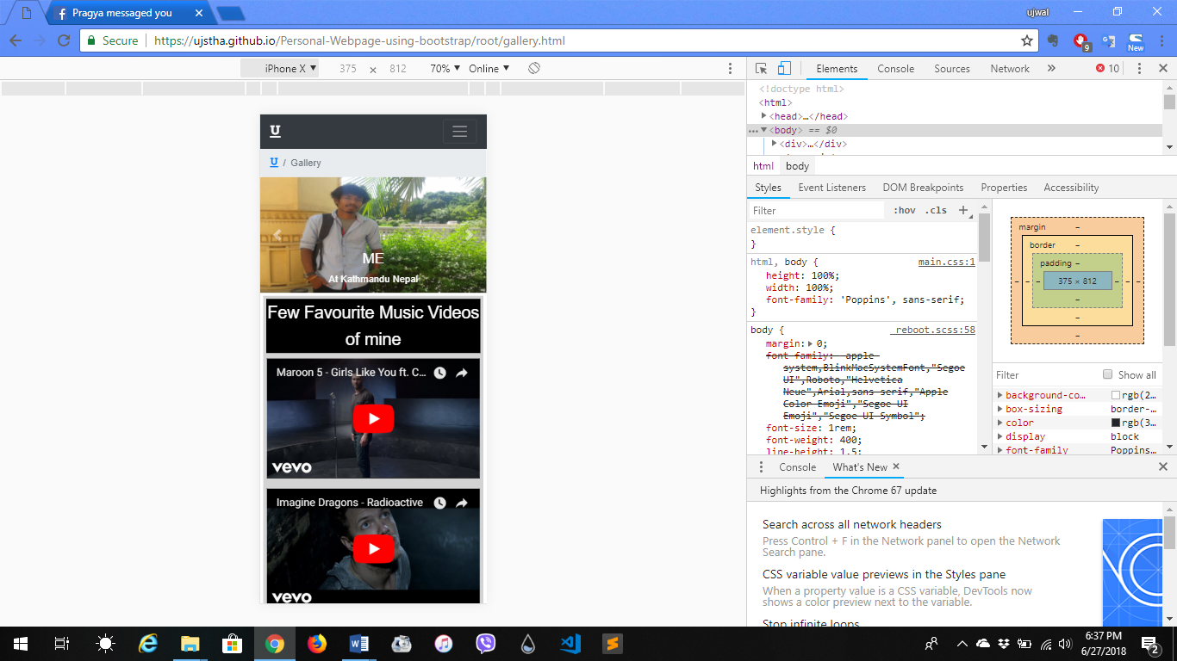

**Description:** This page is designed using Carousel component and Embed utility of bootstrap. Carousel is used to show my old as well as latest pictures with a caption describing when and where it was taken. My favorite music videos from youtube are embedded using embed utility and card component to place those embed videos and collapse to load more that are hidden in the beginning.

**Page:** References.html

**Screenshots:**

**Large Size: Laptop**

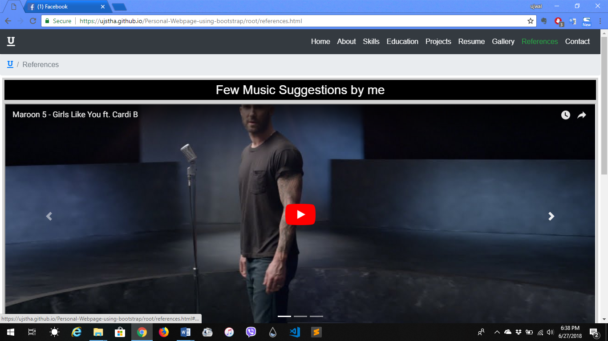

**Medium Size: iPad Pro**

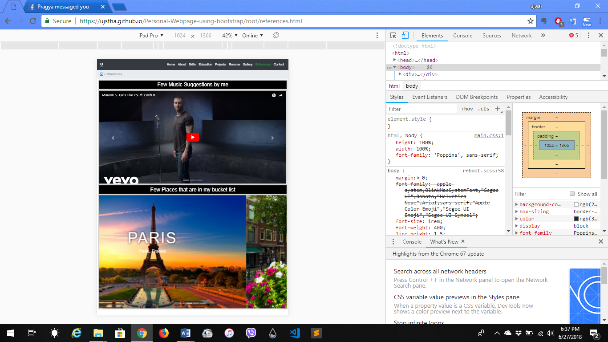

**Small Size: Galaxy S5**

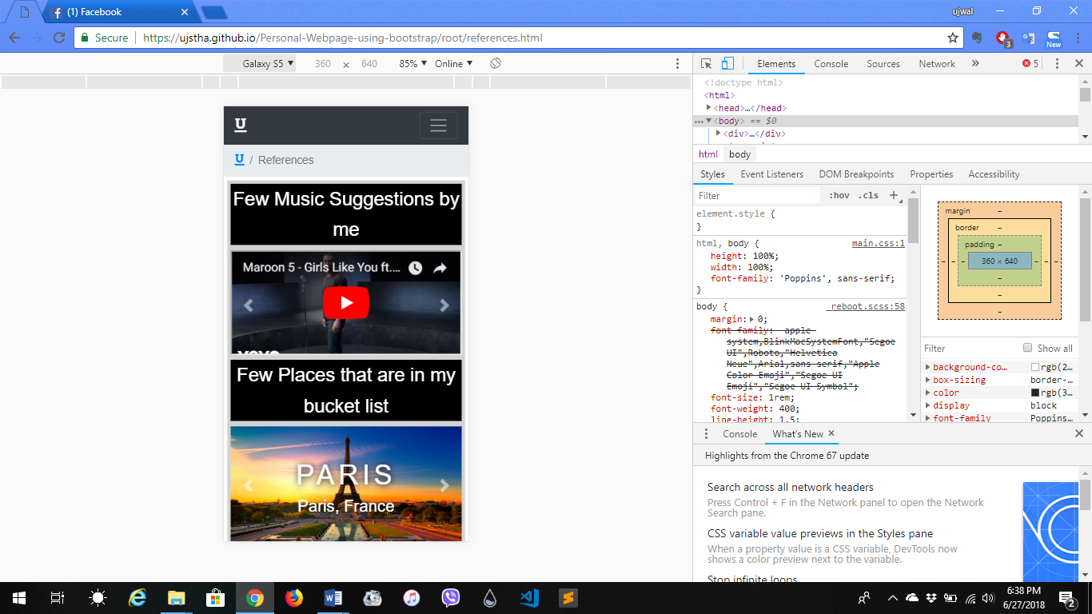

**Extra Small Size: iPhone X**

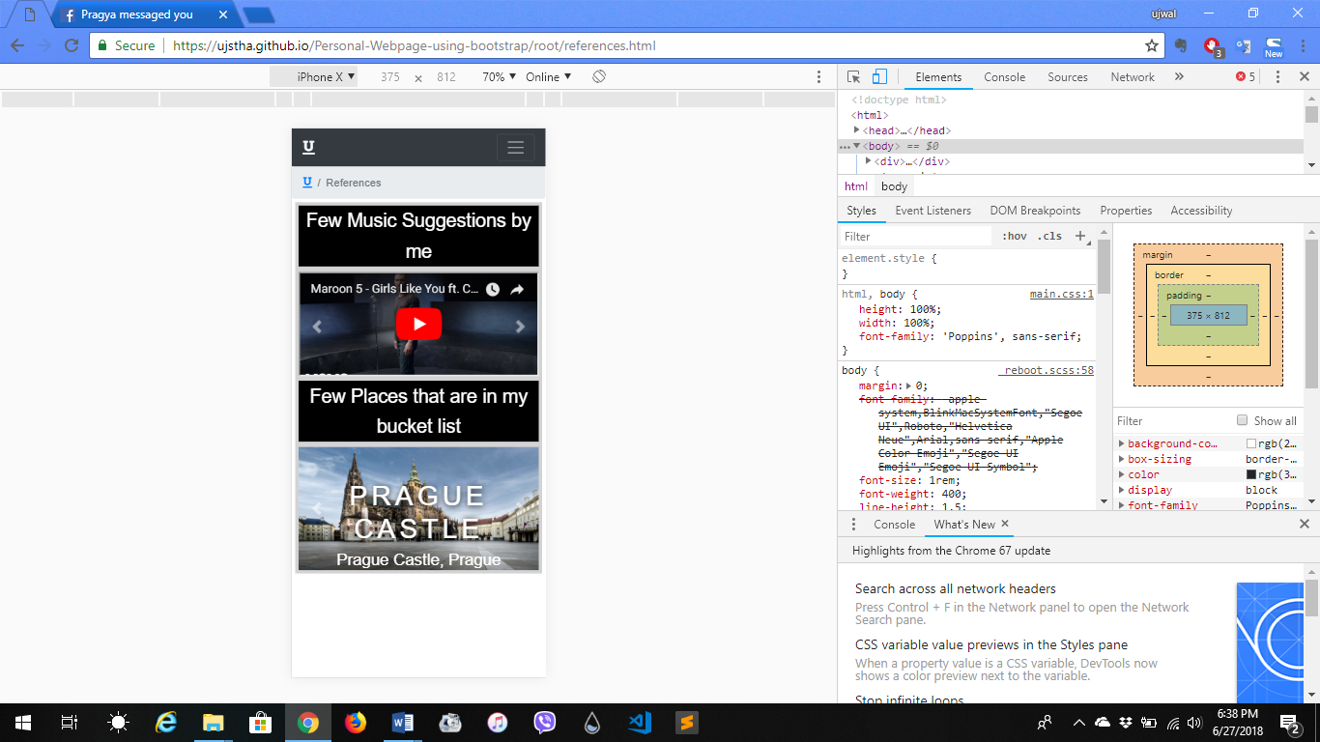

**Description:** This page is designed using Carousel component and Embeds utility of bootstrap. There are two carousel used one with auto slide and captions while other consist of embeds videos from youtube which is some suggestion from me to listen. Other carousel consists places that I plan to visit someday.

**Page:** Contact.html

**Screenshots:**

**Large Size: Laptop**

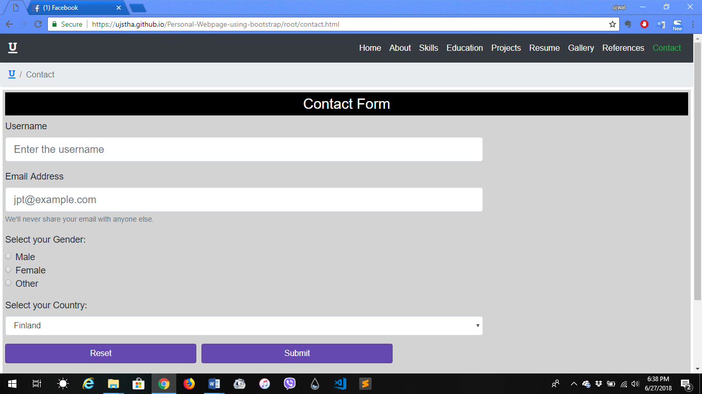

**Medium Size: iPad Pro**

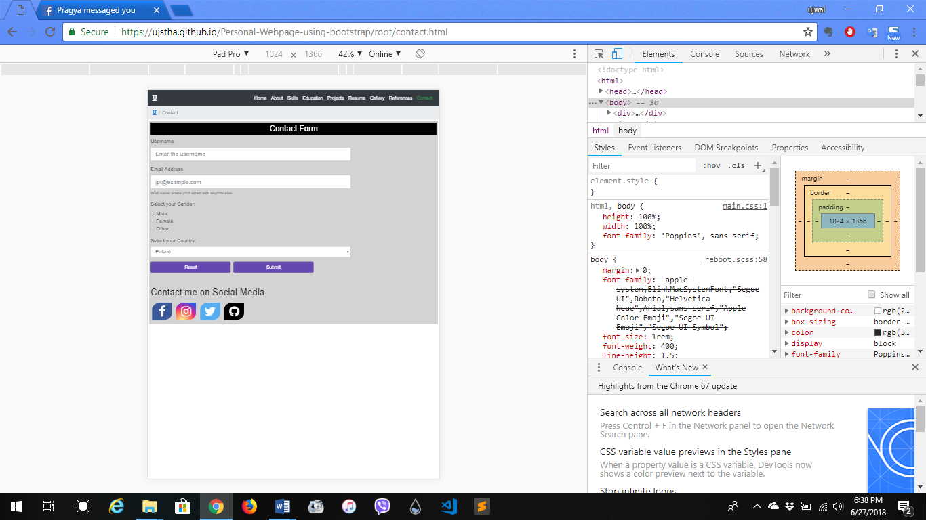

**Small Size: Galaxy S5**

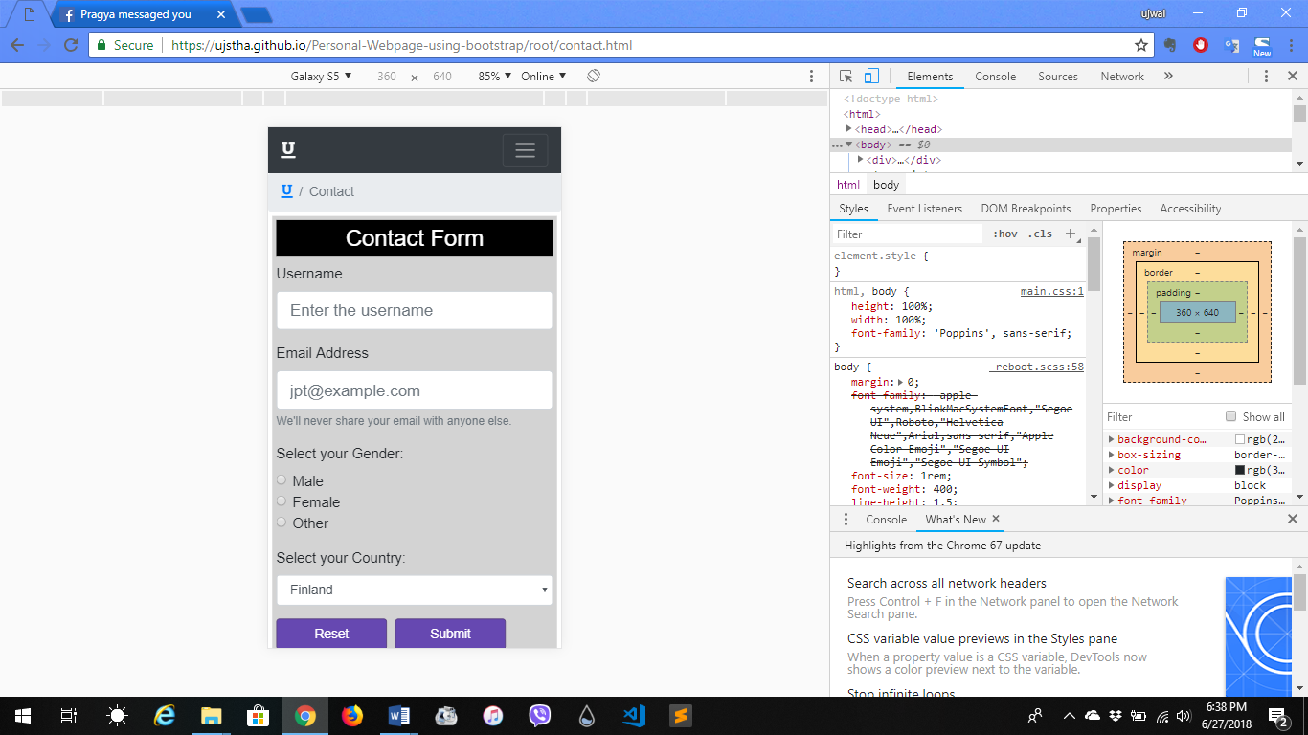

**Extra Small Size: iPhone X**

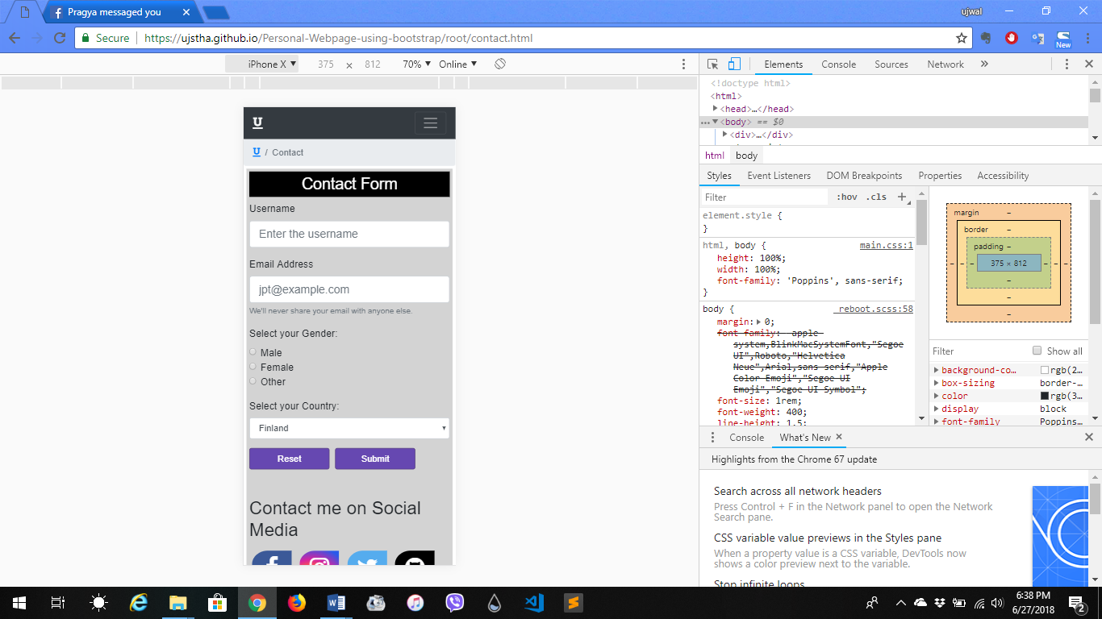

**Description:** This page is designed using Form, Input group, Radio button, Dropdowns, Buttons and Alerts component of bootstrap. Input group was used to create a blank space to fill name and email of the user, Radio button was used to make a selection of gender, Dropdowns were used to make a list of option of countries to choose, Buttons were used to make two buttons one for submission of the form and other for clearing out the form. Lastly alerts were used to warn or inform used about their contact form. This page also contains my social media account link to which user can contact me on.

**How it went?**

The course was quite productive for me since I have never used bootstrap to make responsive webpage. I learned how all the components, utilities and contents work. I also learned how to link bootstrap’s CSS and JavaScript CDN into a html page for bootstrap to be used.